1. **In the figure below, a configuration of four closed surfaces and three charges of -**2Q, +Q**, and**-Q**is shown. What is the electric flux through each surface?**

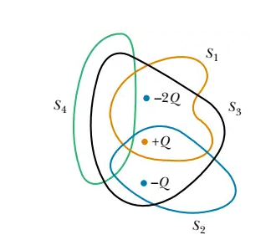

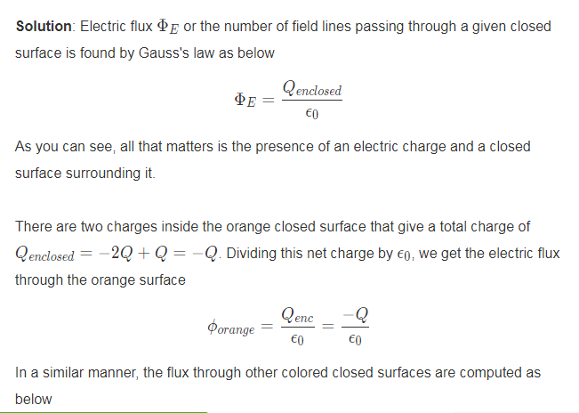

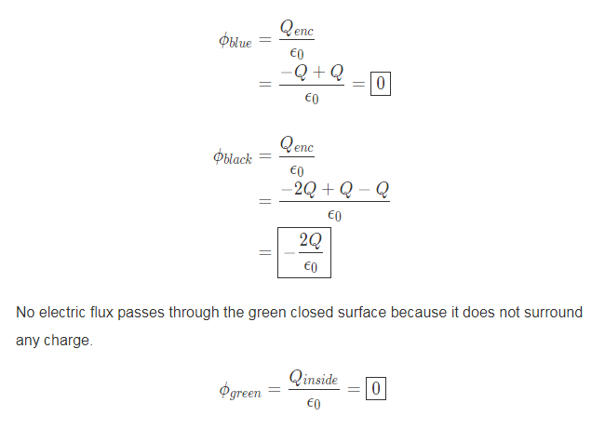

1. In the Fig, a proton is at a distance d/2 directly above the center of a square of side d. What is the magnitude of the electric flux through the square? (Hint: Think of the square as one face of a cube with edge d.)

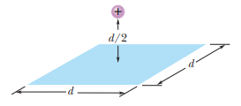

Solution:

To exploit the symmetry of the situation, we imagine a closed Gaussian surface in the shape of a cube, of edge length d, with a proton of charge q = + 1.6 x 10-19 C situated at the inside center of the cube. The cube has six faces, and we expect an equal amount of flux through each face. The total amount of flux is Φnet = q/ε0, and we conclude that the flux through the square is one-sixth of that. Thus,

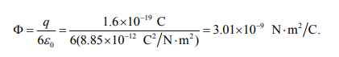

1. At each point on the surface of the cube shown in the following Fig., the electric field is parallel to the z axis. The length of each edge of the cube is 3.0 m. On the top face of the cube the field is E = -34k N/C and on the bottom face it is E = + 20k N/C. Determine the net charge contained within the cube.

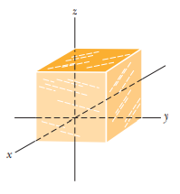

Solution:

There is no flux through the sides, so we have two “inward” contributions to the flux, one from the top (of magnitude [ (34)(3.0)2] and one from the bottom of magnitude[(20)(3.0)2] With “inward” flux being negative, the result is Φ = – 486 N⋅m2 /C. Gauss’ law then leads to

Magnitude of Flux from top (inward) = ᶲt = E. A = (34) (3)2 = 306 N. m2/C

Magnitude of Flux from bottom (inward) = ᶲb = E.A = (20) (3)2 = 180 N. m2/C

So, Total Inwards E – field = 306+ 180 = 486 N.m2

Applying Gauss’s Law

*qenc = €0 Φ = (8.85 x 10-12 C2 / N. m2)( 486 N. m2 /C)= 4.3 x 10-9 C*

*As both the E- field are going inward, so there must be a –ve charge present inside the Gaussian cube.*